**Overview:** the first part of this doc has some leftover changes. The last part has info on our Pilot!

**Shapes**

- Remove the bit about questions getting harder…

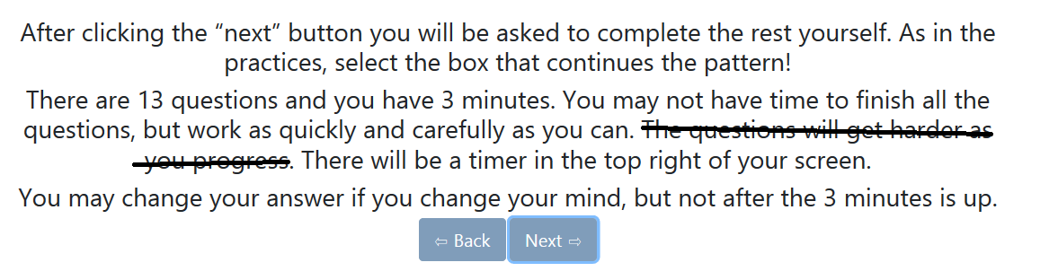

**Cryptography**

**-** Small word change

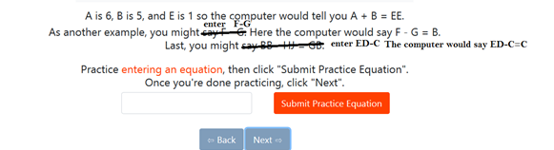

* Is it possible to make the error message for equations have a little explanation afterwards? I was thinking of something like the sentence below “Write an equation…”:

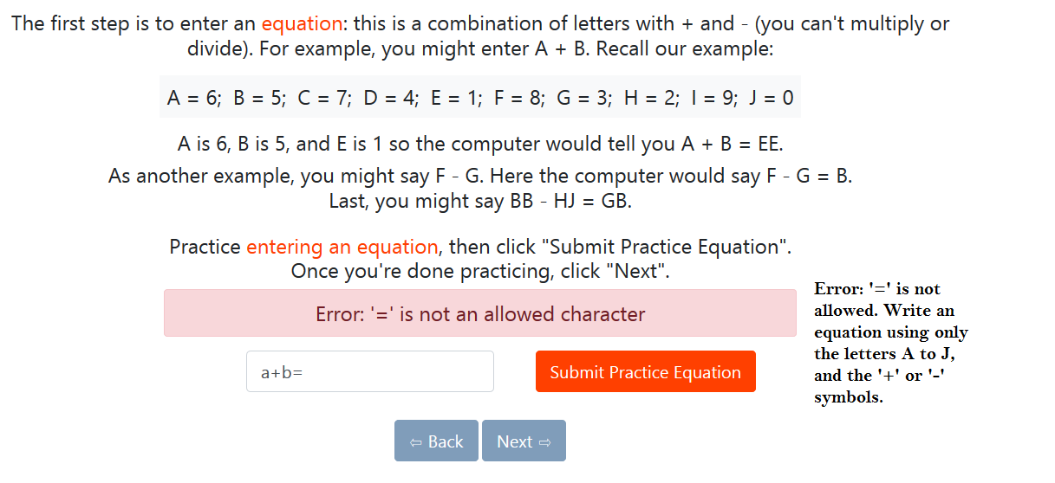

* Quite a few people got the “=” error. I don’t suppose it’s easy to allow people to include “=” [i.e. have the field ignore the symbol]?
* Word change in the instructions

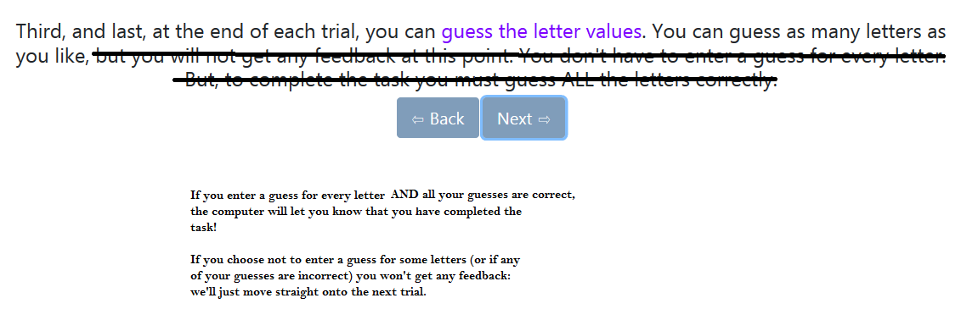

* For consistency, at the end of the crypto task can we have the following page *for everyone* including people who ran out of time or used all their guesses.

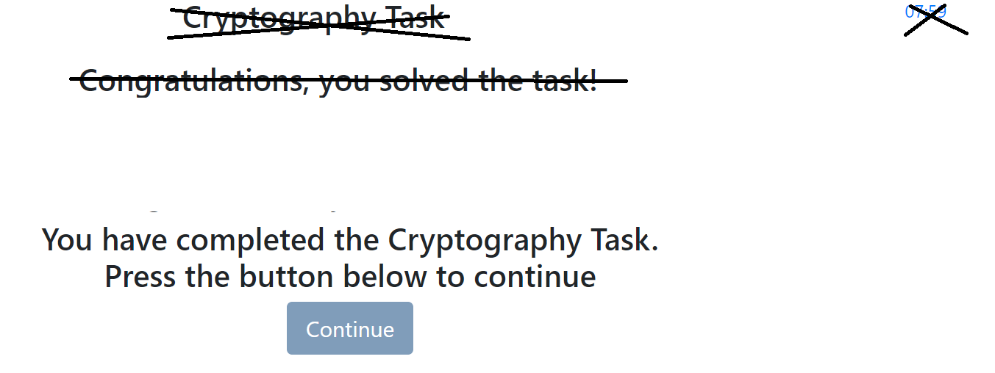

[At the moment, I think it still says “Congratulations, you solved the task”, even for people who get timed out; let’s just remove the congratulations across the board]



**Memory**

Images

- Shift the instructions to the page *before* we show the 6 faces. i.e.

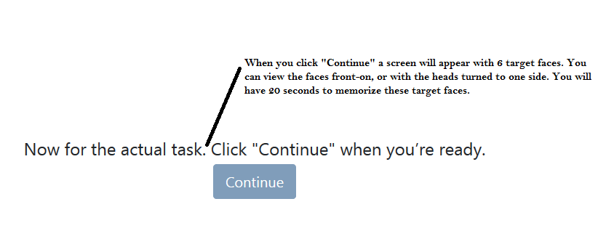

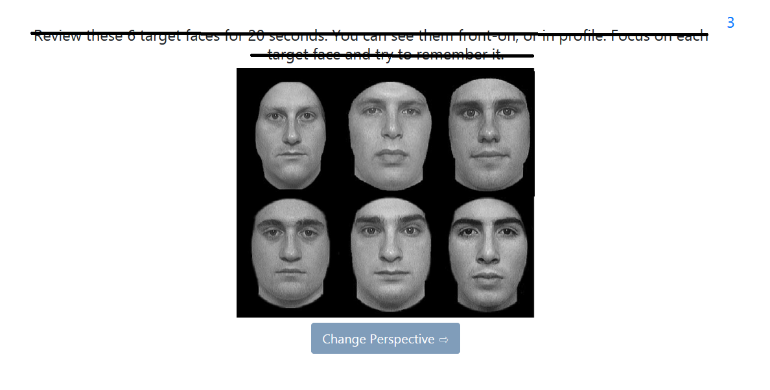

**-** A small word change (which we’ll need to make twice; both before and after things get blurry)

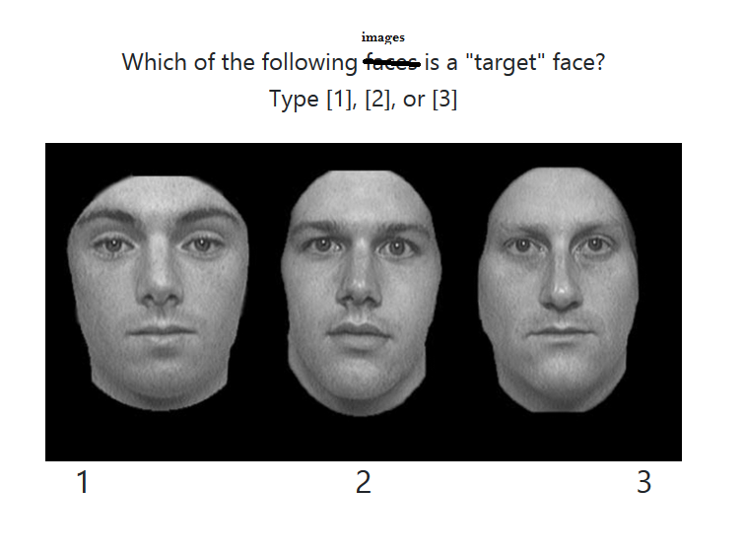

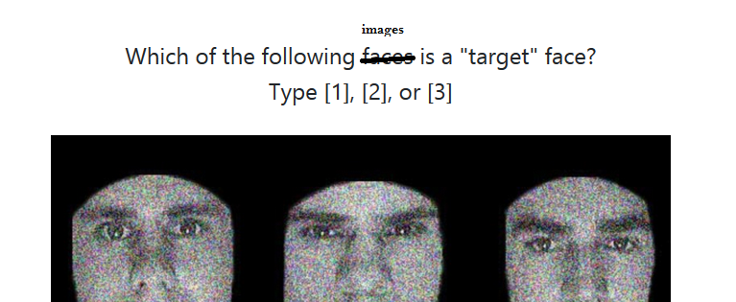

**-** Word change for word memory: (am I right that it’s hard to change the label on the button to “Start Task”? If so, no worries. The text should probably do the job).



**-** Same for story memory:

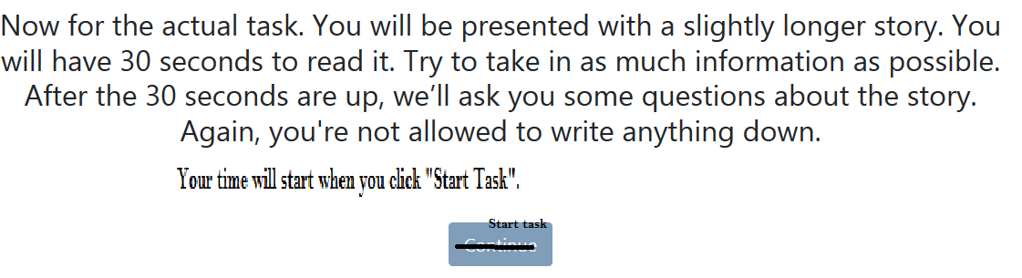

**-** Something a little strange seems to have happened with the word memory. Two people, id45 and id79, somehow skipped a question (where the options were “Boat, Penny, Cat”). I forgot to ask you about this. Would you mind taking a look at this?

- We need to make it clear that we’re only providing feedback on the memory tasks. i.e. “Across the three different memory tasks, you did best on the word memory”.

- At this stage, I think we just tell everyone that they did best on faces…? Note, **we don’t actually need to provide feedback to the Turkers in our pilot**. If it’s a hassle to remove, feel free to keep it. We’ll need it for our group experiment.

- Last and importantly: I noticed that I’d made two mistakes on the word memory task. Specifically, there are two CORRECT answers that I failed to mark as correct (PEARL and CAVE)

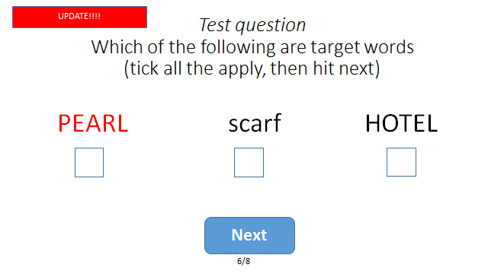

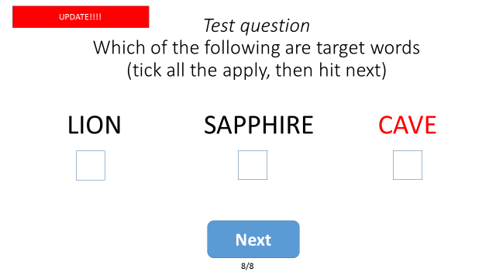

**Optimization**

**-** Word change

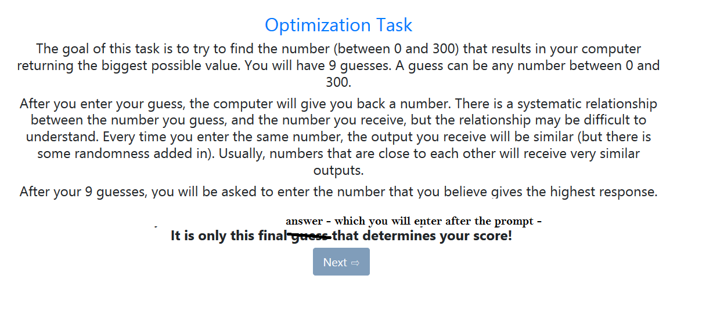

**Data Site**

Having the website has been so much fun! I’ve had an excellent time looking through people’s data and analysing how they did. There are two things I’d like to discuss: scoring and “time” data.

1. Scoring

* Cryptography: there are three elements that will into the final score
  + We need info on how many letters people got correct on their final attempt**.** After each Guess The Values, can we measure how many a person got correct?
* Word memory
  + As discussed. We just want a score from 0-3 for each set of 3 words.

2. Timing

* It would be great to get more time data, **especially for the pilot.**
* Can we measure both “task time” and “reading instruction time”?
  + There’s a concern that some people will spend ages on “instructions” [and we might be under-budgeting how long everything will take]. A related concern is that people might gain an advantage by spending ages on the instruction section for cryptography [i.e. they’ll use a lot of time devising a clever strategy before the 10 minutes begins].
* I’m also not clear on exactly when the clock starts for some tasks. If you could check to see that the clock for “task time” always starts when someone clicks through to a task [rather than instructions] that would be excellent.

**Piloting our tasks on MTurk!!**

* The aim is to have 4 different “blocks” [i.e. batteries] of tasks. Every battery will have:
* The cryptography taskx2 [we want people to do this twice, sequentially, to get a sense of how much they improve with a practice]
* The first Shapes test [the one we have coded at the moment]
* Eyes [RMET]
* 4 Optimization functions
* 2 memory tests [each test includes ‘words’; ‘images’; ‘stories’]
* 2 Team Role Test scenarios
* A participant will be assigned to one block only
* We have different versions of the shapes, optimization, memory and Team Role Tests. To make different versions as clear as possible, I’ve made a [folder](https://drive.google.com/drive/folders/1N3nTSi3eXtvau-orlIPwlA9itSN37JFf?usp=sharing) on Google drive. This has a bunch of sub-folders. The optimization folder, for example, has a word doc that makes it obvious which optimization functions are 1,2,3 etc…

Block A:

* 2xcryptography
* Shape test 1 [this is the same for each block, and the one we’re using in our informal pilot]
* RMET
* Optimization functions: 1,2,3,4 [see the word doc on Google Drive in the “Optimization” folder]
* Memory tests 1 and 2
* Team Role Test 1 and 2

Block B:

* 2xcryptography
* Shape test 1
* RMET
* Optimization functions: 4,3,5,6
* Memory tests 2 and 3
* Team Role Test 2 and 3

Block C:

* 2xcryptography
* Shape test 1
* RMET
* Optimization functions: 6,5,7,8
* Memory tests 3 and 4
* Team Role Test 3 and 4

Block D:

* 2xcryptography
* Shape test 1
* RMET
* Optimization functions: 8,7,2,1
* Memory tests 4 and 1
* Team Role Test 4 and 1